Picture 1: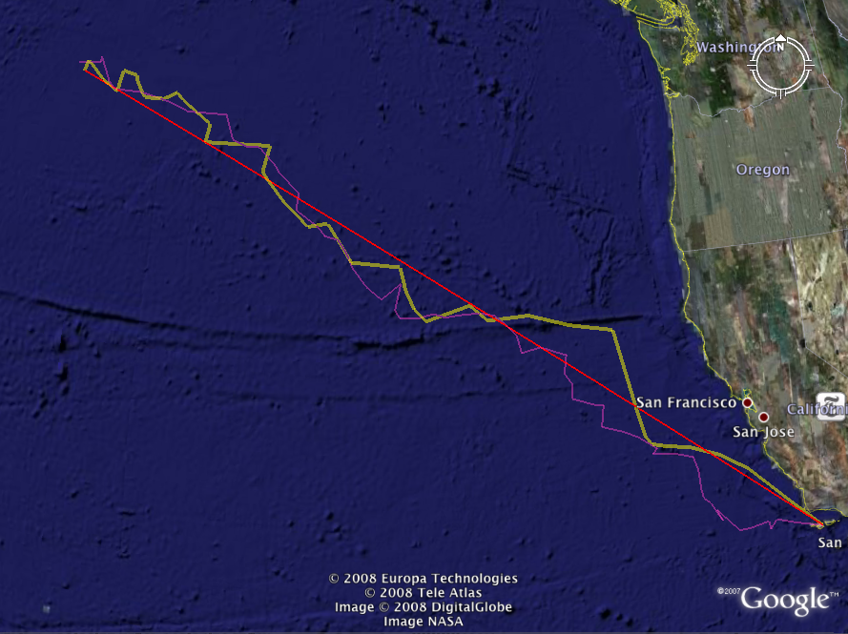
> tr5 = GCRandomWalk(120*(pi)/180, 34*(pi)/180, 147.2*(pi)/180, 46.7*(pi)/180, spe = 0.0068, sig = 0.004)
> tr5[,1] = sapply(tr5[,1], neg)
> tr5[,2] = sapply(tr5[,2], r2d)
> tr5[,1] = sapply(tr5[,1], r2d)
> GreatCircleKML(tr5,2)
> tr5
[,1] [,2]
[1,] -120.0000 34.00000
[2,] -120.9179 34.22172
[3,] -121.6859 34.44228
[4,] -121.9228 34.19784
[5,] -121.9703 34.42722
[6,] -122.6624 34.32883
[7,] -123.0319 34.31941
[8,] -123.7892 34.98540
[9,] -123.6144 34.67895
[10,] -123.9921 35.19903
[11,] -124.2321 35.36636
[12,] -124.2939 35.62079
[13,] -124.3589 36.15975
[14,] -124.5061 36.52147
[15,] -125.0824 36.66569
[16,] -125.8961 36.72923
[17,] -125.7328 36.86852
[18,] -126.3250 37.20652
[19,] -126.8440 37.40262
[20,] -127.5676 37.57798
[21,] -127.4800 38.13841
[22,] -127.7326 38.16494
[23,] -128.5241 38.37331
[24,] -128.4970 38.75919
[25,] -128.7499 39.03512
[26,] -128.6583 39.52918
[27,] -128.8816 39.58425
[28,] -129.5354 39.76603
[29,] -130.1758 39.62850
[30,] -130.3198 40.08102
[31,] -130.6716 40.37815
[32,] -131.0972 40.64813
[33,] -131.1532 40.63950
[34,] -131.5598 40.70091
[35,] -132.2911 40.65289
[36,] -132.7473 40.59997
[37,] -133.1271 40.69099
[38,] -133.3701 40.64985
[39,] -133.5922 40.59365
[40,] -134.2968 40.58473
[41,] -134.4620 40.78123
[42,] -134.2708 41.47321
[43,] -134.9317 41.05659
[44,] -135.4511 41.37117
[45,] -135.9504 41.84767
[46,] -136.1733 42.21661
[47,] -136.4949 42.57440
[48,] -136.9876 42.67665
[49,] -137.2247 42.89536
[50,] -138.0649 43.32625
[51,] -137.9964 43.76078
[52,] -138.8040 44.31385
[53,] -138.9566 44.48950
[54,] -139.6042 44.94767
[55,] -140.0930 44.94687
[56,] -140.6485 45.11395
[57,] -141.0044 45.78028
[58,] -142.5483 45.80228
[59,] -143.2932 46.01608
[60,] -143.9512 46.13835
[61,] -144.6569 46.23837
[62,] -145.7196 46.25716
[63,] -146.0251 46.46357
[64,] -146.5602 47.13212
[65,] -146.5743 46.97924
[66,] -147.5325 46.92272
picture2:
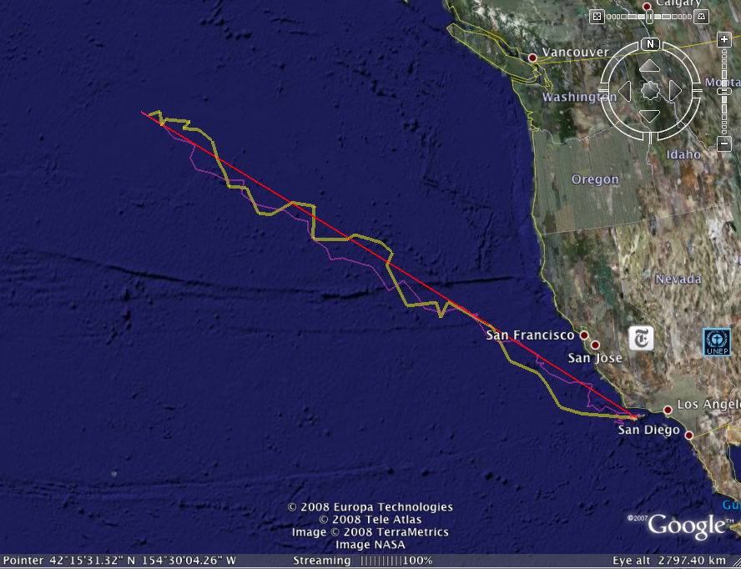
> tr6 = GCRandomWalk(147.2*(pi)/180, 46.7*(pi)/180, 120*(pi)/180, 34*(pi)/180, spe = 0.0068, sig = 0.004)
> tr6[,1] = sapply(tr6[,1], neg)
> tr6[,2] = sapply(tr6[,2], r2d)
> tr6[,1] = sapply(tr6[,1], r2d)
> tr6
[,1] [,2]
[1,] -147.2000 46.70000
[2,] -146.9098 46.62381
[3,] -145.7371 46.26599
[4,] -145.4219 46.11694
[5,] -144.8370 45.77159
[6,] -143.9084 45.65863
[7,] -143.4753 45.53430
[8,] -143.6451 45.01571
[9,] -143.2115 44.57348
[10,] -142.2233 44.47184
[11,] -141.4774 44.26044
[12,] -140.3790 44.28675
[13,] -140.4452 43.75241
[14,] -140.3662 43.70147
[15,] -139.5032 43.34534
[16,] -138.6331 43.24034
[17,] -137.9707 43.18210
[18,] -137.3999 42.87757
[19,] -136.7158 42.78881
[20,] -136.6958 42.43136
[21,] -136.3991 42.13855
[22,] -136.3342 42.05043
[23,] -135.6556 41.75210
[24,] -135.4343 41.31204
[25,] -134.8308 41.37973
[26,] -133.5390 41.09968
[27,] -133.3128 41.07800
[28,] -132.8476 40.62923
[29,] -132.4202 40.10143
[30,] -131.6578 40.49908
[31,] -130.9281 39.82028
[32,] -130.6130 39.38622
[33,] -129.7689 39.21107
[34,] -128.6757 39.36986
[35,] -128.2020 39.05830
[36,] -127.9563 39.06357
[37,] -127.8674 39.02031
[38,] -128.2124 38.96306
[39,] -127.8579 38.70686
[40,] -127.4991 38.18051
[41,] -126.9077 37.88764
[42,] -125.9195 37.90511
[43,] -125.6858 37.65258
[44,] -124.9442 37.23351
[45,] -125.0672 36.91051
[46,] -124.6714 36.87792
[47,] -124.8879 36.80501
[48,] -124.4119 36.42465
[49,] -123.4099 35.92616
[50,] -123.0952 35.94610
[51,] -122.2152 35.73676
[52,] -122.5062 35.30839
[53,] -122.4492 35.05322
[54,] -122.6075 34.84029
[55,] -122.5833 34.85782
[56,] -122.3113 34.87454
[57,] -121.9258 34.56208
[58,] -121.6401 34.75450
[59,] -120.9076 34.35477
[60,] -120.3588 34.28614
[61,] -120.2720 33.98040
[62,] -119.7872 34.13612
[63,] -121.2470 34.02928
[64,] -120.7106 33.87015
[65,] -120.9638 34.07567
[66,] -121.0806 34.38291

